**Day 8 Assignment - 12/12/2023 - Vamsi Viswanadham**

Worked on the Below Concepts.

* **Python and its Features**

Python was developed by Guido van Rossum (a Dutch programmer) in 1991. Python is a High-Level Language (whereas C and Java are not High-Level Language)

Features of Python:

* Simple and Readable: Python's syntax is clear and simple, resembling English sentences, making the code easy to read and write.
* Easy to Learn: Python has a straightforward syntax, making it accessible for beginners and easy to pick up compared to languages like C or Java.
* Free and Open Source: Python is open-source, meaning it's freely available for use, modification, and distribution.
* High-Level Language: Python abstracts complex details of computer operation, focusing on coding logic rather than system specifics.
* Dynamically Typed: Python automatically infers the type of a variable during runtime, unlike some languages that require explicit declaration.
* Portable and Cross-Platform: Python works on various platforms like Windows, Linux, and macOS without needing code modifications.
* Interpreted: Python code is executed directly, without the need for prior compilation into machine language.
* Multiparadigm: Supports various programming styles like Object-Oriented, Procedural, and Functional programming.
* Extensible: Python can integrate with other languages like C or C++, allowing for optimization of performance-critical parts.
* Extensive Libraries: Offers a vast standard library and third-party modules for various tasks, from web development to data analysis.
* Automatic Memory Management: Python handles memory allocation and garbage collection automatically, easing the burden on the programmer.
* **History of the Python**

**Origin:** Guido van Rossum began developing Python in the 1980s, with the name inspired by the British comedy "Monty Python", not the snake.

**Initial Release:** The first version, Python 0.9.0, was released in February 1991 in the Netherlands.

Major Releases:

Python 1.0 in January 1994.

Python 2.0 in October 2000.

Python 3.0 in December 2008.

Subsequent Updates:

Python 2.6 in October 2008.

Python 2.7 in July 2010.

Python 3.4 in March 2014.

Python 3.6 in December 2016.

Python 3.7 in June 2018.

**Two Major Versions:** Since 2008, Python has two active versions, 2.x and 3.x, both popular in various communities.

**Code Compatibility:** Versions 2.x and 3.x are not fully code-compatible. There are syntactical and other differences.

* **Writing and Running First program**

Here is the first Hello world program in Python:

print(“Hello World”) #This will print Hello World in the terminal.

Here is a screenshot of the work.

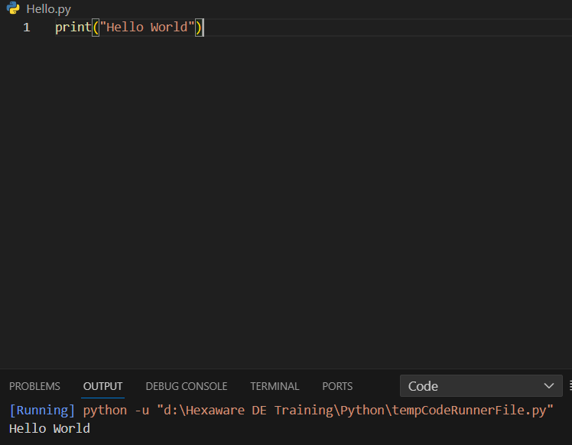

* **Keywords & Identifiers**
* **Variables & Operators**
* **Data Types**
* **Numeric**
* **Sequence**
* **Boolean**

We can declare the variables of any type without any type declaration as shown below.

a = 3 #integer

b = "Hello" #string

c = 0.49 #float

d = True #boolean

e = complex(3, 5) #complex variable.

Here is a screenshot of the work

